Burleson High School
Internetworking Job Exhibit

Picture of students with project

Students: Thomas Ash, Ben Landon, Travis Koehn, Noah Sharp

Skills USA
Chapter ID 3849

Scott Stephenson, Advisor
- Summary 1
- Project Goals 2
- Topology 3
- Equipment List 4
- Configuration of Switches 5
- Configuration of Routers 9
- Pictures of Project Build 15
- Resumes 20
- Conclusion 24
- Advisor’s Statement 25

This exhibit was made in order to show a network functioning correctly for a metaphorical company. The project was started in mid-January and completed in early February. We worked on it as a group and worked hard in order to ensure that the project was to be completed in a timely manner and in working condition. We ran into some minor problems when configuring the switches but were fixed easily with the knowledge we obtained while studying and preparing for the project. The skills we acquired while doing this network exhibit will help us a lot in our future pursuing our various fields in technology. Whether it be networking, computer maintenance, or programming.

The switches were donated by Mike Meyers and the rest of the items were obtained through some of the various members of our group. We configured all four routers and three switches using various protocols. We connected the routers using 3 serial cables, the switches are connected to the routers using straight through cables in the interface FAO/0 and FAO/1 for router 1.

The reason we use DHCP is because the company is supposed to have multiple amounts of computers that we need to manage manually. The IP addresses we used for the DHCP are 10.1.0.1.255.255.255.0; 10.2.0.1 255.255.255.0; and 103.0.1 255.255.255.0, all of which are class A IP addresses.

The other IP's we used for the serial connections were class C addresses. 192.168.0.1 on the first DHCP, 192.168.0.5 255.255.255.252 on the second, and 192.168.0.9 255.255.255.252 on the third. The routing protocols we used are RIPv2, EIGRP, OSPF, and ISIS.

I built this computer in order to have a computer to help me in high school and eventually in college. I built this computer for two purposes: schoolwork and online gaming. Building this computer helped me by furthering my knowledge as a computer technician and I can strive to further my knowledge of graphic design. In college I plan on majoring in Graphic Design and I hope that with building this computer, I can continue to try to experiment with new things and become a better designer.

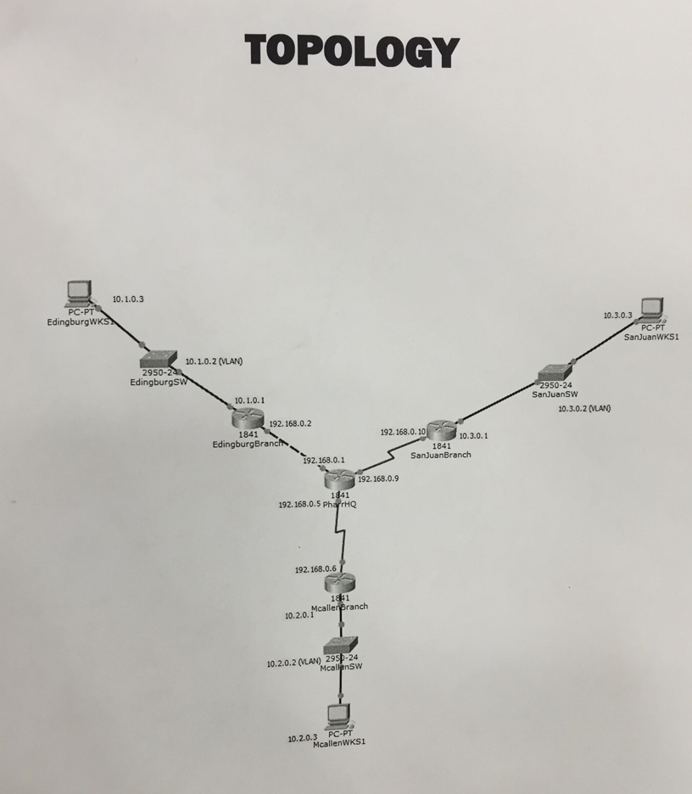

Resumes

As a present to myself, I built my first computer for personal use I had never built a computer before, but by listening to my teacher throughout the school year. I had applied what he taught me and built my gaming computer. By learning and remembering what I had been taught. I had minimal problems building the computer. I feel like this experience has greatly increased my knowledge about computer hardware. In just 3 hours. I had taught myself how to build this computer and by some trial and error and troubleshooting after the build was completed. I only came across one problem when building my computer; my graphics card was almost too large to fit inside my case but after some wire rearranging it fit perfectly. I feel as if this computer will benefit me now and throughout college.

I certify that these students prepared this Internetworking project for the 2015-16 Texas SkillsUSA Competition

Students
Thomas Ash
Ben Landon
Travis Koehn
Noah Sharp

______________________________
Scott Stephenson, Advisor
Burleson High School
February 19, 2015

